Macro
- A macro (or macro instruction)
  - It is simply a notational convenience for the programmer.
  - It allows the programmer to write shorthand version of a program
  - It represents a commonly used group of statements in the source program.
- For example:
- Suppose a program needs to add two numbers frequently. This requires a sequence of instructions. We can define and use a macro called SUM, to represent this sequence of instructions.

SUM MACRO &X,&Y LDA &X
MOV B
LDA &Y
ADD B MEND

Macro Preprocessor
- The macro pre-processor(or macro processor) is a system software which replaces each macro instruction with the corresponding group of source language statements. This operation is called expanding the macro.
- It does not concern the meaning of the involved statements during macro expansion.
- The design of a macro processor generally is machine independent.

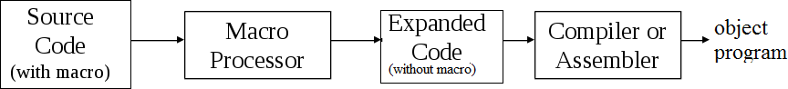

BASIC MACRO PROCESSOR FUNCTIONS

The fundamental functions common to all macro processors are: ( Code to remember - DIE )
    - Macro Definition
    - Macro Invocation
    - Macro Expansion

Macro Definition
- Macro definitions are typically located at the start of a program.
- A macro definition is enclosed between a macro header statement(MACRO) and a macro end statement(MEND)
- Format of macro definition
macroname MACRO parameters
:
body
:
MEND

- A macro definition consist of macro prototype statement and body of macro.
- A macro prototype statement declares the name of a macro and its parameters. It has following format:
macroname MACRO parameters
where macroname indicates the name of macro, MACRO indicates the beginning of macro definition and parameters indicates the list of formal parameters. parameters is of the form &parameter1, &parameter2,…Each parameter begins with ‘&’. Whenever we use the term macro prototype it simply means the macro name along with its parameters.
- Body of macro consist of statements that will generated as the expansion of macro.
- Consider the following macro definition: SUM MACRO &X,&Y
LDA &X
MOV B
LDA &Y
ADD B MEND
Here, the macro named SUM is used to find the sum of two variables passed to it.

Macro Invocation(or Macro Call)
- A macro invocation statement (a macro call) gives the name of the macro instruction being invoked and the arguments to be used in expanding the macro.
- The format of macro invocation
macroname p1, p2,...pn
- The above defined macro can be called as SUM P,Q

Macro Expansion
- Each macro invocation statement will be expanded into the statements that form the body of the macro.
- Arguments from the macro invocation are substituted for the parameters in the macro prototype.
- The arguments and parameters are associated with one another according to their positions. The first argument in the macro invocation corresponds to the first parameter in the macro prototype, etc.
- Comment lines within the macro body have been deleted, but comments on individual statements have been retained. Macro invocation statement itself has been included as a comment line.
- Consider the example for macro expansion on next page:
In this example, the macro named SUM is defined at the start of the program. This macro is invoked with the macro call SUM P,Q and the macro is expanded as
LDA &P
MOV B
LDA &Q
ADD B MEND
Again the same macro is invoked with the macro call SUM M,N and the macro is expanded as

LDA &M
MOV B
LDA &N
ADD B MEND
Figure: Example for macro expansion
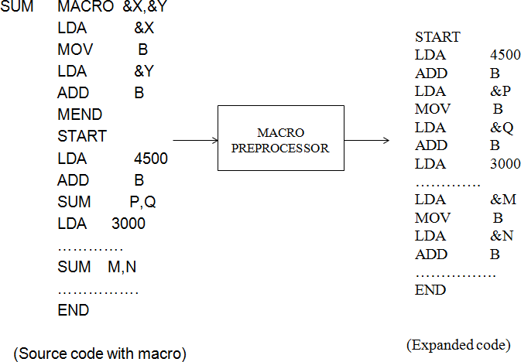

Difference between Macro and Subroutine
Macros differ from subroutines in two fundamental aspects:
- A macro call leads to its expansion, whereas subroutine call leads to its execution. So there is difference in size and execution efficiency.
- Statements of the macro body are expanded each time the macro is invoked. But the statements of the subroutine appear only once, regardless of how many times the subroutine is called.

